YOUR SCHOOL LOGO HERE

Videos to help you support your child’s learning

[School name] is delighted to be working with TT Education, the UK’s leading school improvement company to bring you ZingiTT. This innovative new parent engagement portal contains dozens of short videos to help you support child’s learning from home.

For just £5.99 a month, you will get dozens of videos explaining those strange terms we use in school these days. Each video has ideas for some fun activities you can do at home to help your children with their learning. Most are just 3 or 4 minutes, meaning that you can watch the videos whilst you’re on the go on your phone or mobile device. Topics include:

- English, maths, science, emotional support and more;
- how to approach phonics at home;
- how to challenge your child without pushing them;
- moving into a new class;
- de-stressing in the run up to SATs;
- how do children’s brains actually work – and how does that information help me?

You’ll get access to monthly webinars and blog articles on some of the most topical and interesting educational news and ideas. [School name] will also receive £5 of your subscription amount to put towards teacher training and school improvement. Not bad, right?

We really think that Zing-itt is win-win-win.

- Win 1: you’re no longer confused by complicated terminology coming home from school.
- Win 2: your child has someone at home who ‘gets’ school lingo and can decode it with them.
- Win 3: our school receives some funding towards school improvement.

If you are interested, or if you would like to see some sample videos completely free of charge, please visit www.zingitt.co.uk today. Subscribing is easy and you’ll get access straight away.

Your sincerely,

[Headteacher name]
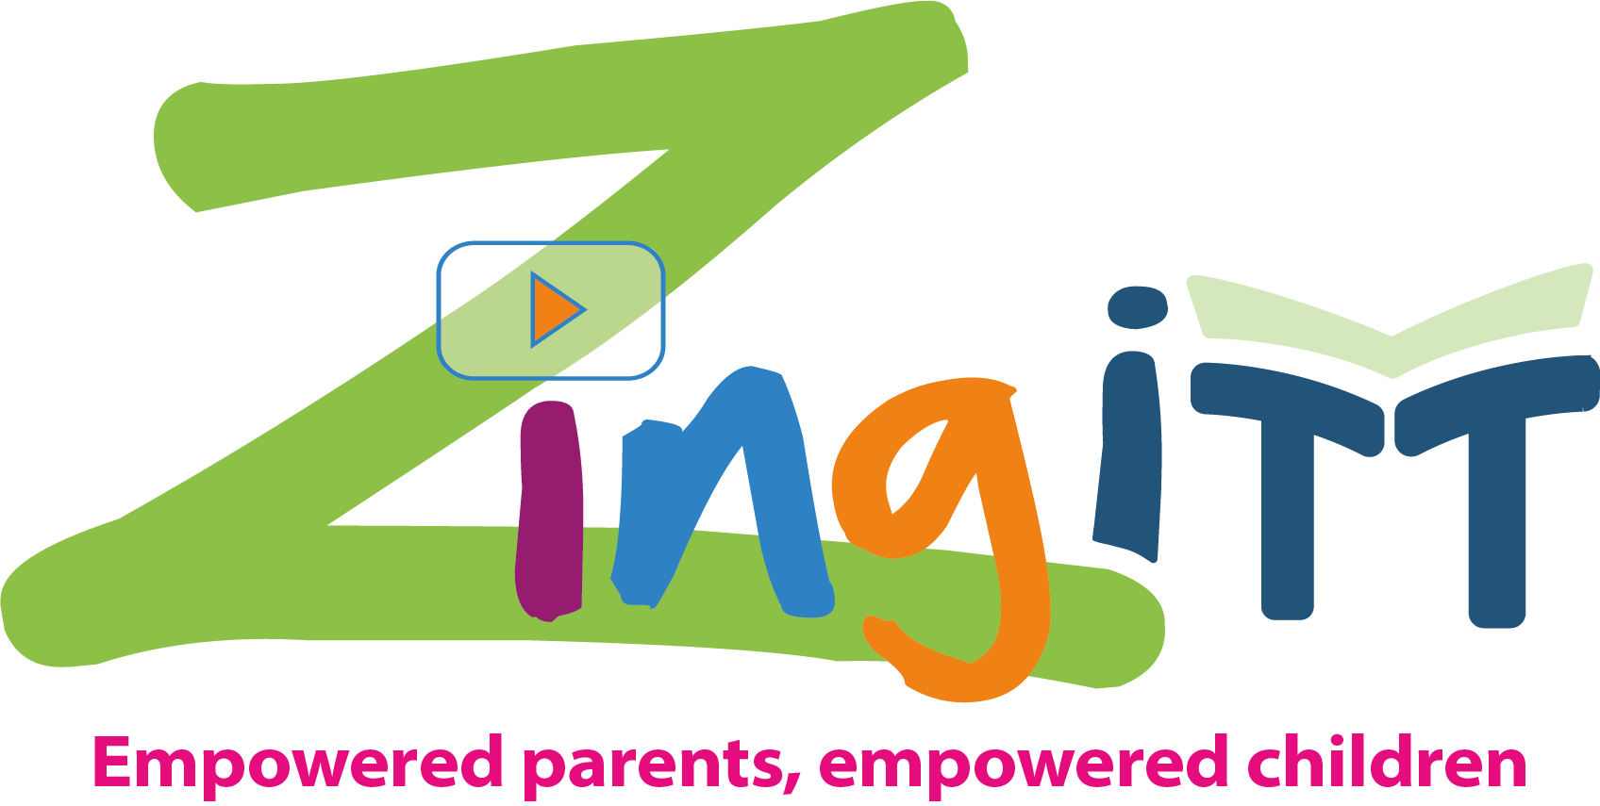
[School name]
Your school logo here

